Hi everybody from my favorite Wednesday CC class!!!

I know and feel you are so very sorry for not having the opportunity to write your British History all-you-know essay next Wednesday, however, here is the task I want you to do instead.

T1 - deadline March 20th, 2020
Send your part 3 British history topic commenting on the most prominent stages, personalities, dates and events, symbols, and other, of British History. And to make this even trickier, I want you to comment also on the pictures you see below and to choose one important or most interesting historical figure who helped to form Britain as we know it today.

In your “essay”, comment on the following pictures and mention the following names:

Hastings Queen Victoria
East India Company Anne Boleyn
Commonwealth Hadrian´s Wall
Stonehenge Brexit

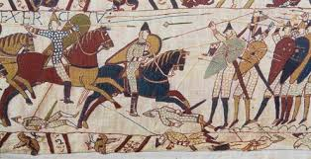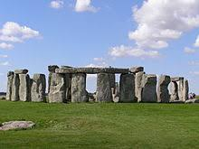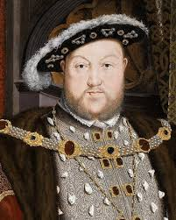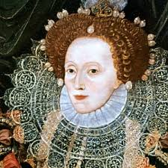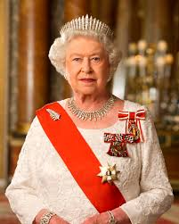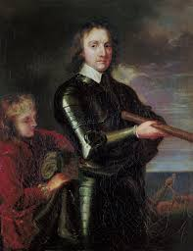
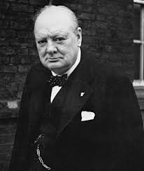

T2 - American History

In the second attachment you will find some read on American History. Please, read through and get ready for testing. When we meet, I will distribute pictures and I will be asking about American History. I understand you will have enough time to read through the text and learn the basic facts about AH. And you may practise speaking about the topic for at least 5 minutes. The testing will be oral, not written this time.

