8. A, 8. B, 4. A – KONVERZACE V AJ
INSTRUCTIONS FOR WORK AT HOME

FROM MARCH 11 TO MARCH 23

Everyone of you has to read a text about a Unesco World Heritage place of interest in the Czech Republic

Carefully read the text, translate all the unknown words and write a summary in points

In other sources find 3 extra information about the place you are supposed to read about and add it to your summary

With two exceptions there are always two people for one topic, that doesn’t mean you have to work in pairs. Work individually.

Send me your summaries by Saturday, March 21 to my email address hamza@gymkrom.cz

Patrik, Lucie – Tugendhat Villa in Brno
Tereza, Ondřej K. – Pilgrimage Church of St John of Nepomuk at Zelená Hora
Aneta, Erik – Litomyšl Castle
Sabina, Jakub K. – Lednice-Valtice Cultural Landscape
Kristýna, Marek – Kutná Hora
Katka, Ondřej S. – Jewish Quarter and St Procopius‘ Basilica in Třebíč
Monika, Jakub Š. – Holy Trinity Column in Olomouc
Adam – Historic Centre of Český Krumlov
Lenka – Holašovice Historic Village
Filip, Natálie – Historic Centre of Telč

IF THE SCHOOL IS STILL CLOSED ON MARCH 27 DO THE TASK BELOW AS WELL

Prepare a 5-10 powerpoint presentation about Prague

(basic information, brief history, most important sights, cultural events, etc.)

IF YOU HAVE ANY QUESTIONS REGARDING THE TASKS, FEEL FREE TO ASK

Tugendhat Villa in Brno
The Tugendhat Villa in Brno, designed by the architect Mies van der Rohe, is an outstanding example of the international style in the modern movement in architecture as it developed in Europe in the 1920s. Its particular value lies in the application of innovative spatial and aesthetic concepts that aim to satisfy new lifestyle needs by taking advantage of the opportunities afforded by modern industrial production.

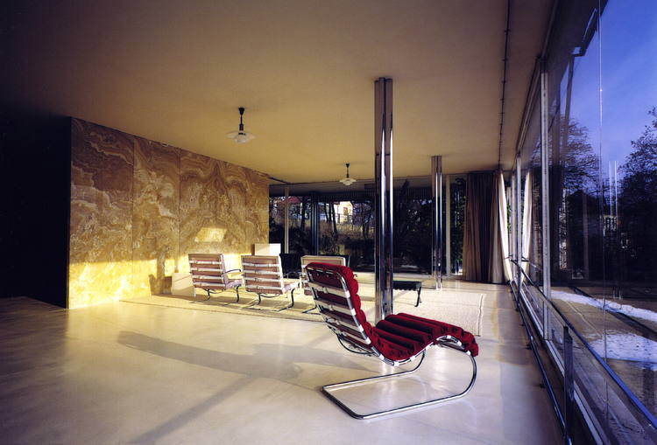

Outstanding Universal Value
Brief Synthesis

The Tugendhat Villa is situated in Brno, in the district of Černá Pole, in the south of South Moravia in the Czech Republic. The villa was designed by the architect Ludwig Mies van der Rohe and built on a commission from Grete and Frits Tugendhat, members of rich industrial families of Brno, in 1929–1930.The prominent German architect Ludwig Mies van der Rohe designed not only the villa but also its furniture and the adjacent garden. Moreover, Mies van der Rohe closely supervised the execution of the building project to achieve perfection.
The Tugendhat Villa in Brno is a pioneering work of modern 20th century residential architecture. It embodies innovative spatial and aesthetic concepts that were developed in housing at that time to meet the new needs arising from the modern way of life, by taking advantage of the opportunities afforded by modern industrial production. Designing the interior residential area as a space without limits determines the architecture of the Tugendhat Villa. The villa also reflects the desire of Mies van der Rohe to create an architecture concentrating on the essential and aiming at the purest expression in each detail as well as in the whole. A winter garden occupies almost two-thirds of the entire floor space of the main floor. Subtle divisions made of rosewood and onyx separate spaces of this same floor, such as the reception hall, the music corner and the library. The living area has large windows and is directly joined to the terrace, which has a wide stairway leading down to the garden. The main structure of the house is made of reinforced concrete slabs supported by steel beams, some of them being polished. The basement includes mechanical equipment of the house, in particular for the central heating and air conditioning, as well as for the electrically operated large windows.
The Tugendhat Villa in Brno is one of the most original projects completed by Mies van der Rohe. He was able to fully implement his design in accordance with his intentions due to the ideal cooperation with the highly cultured Tugendhat family. The furniture was designed by the architect and some pieces were intended for specific locations. There is no other similar architectural work of the European production by Mies van der Rohe that has been preserved with such integrity.
Criterion (ii): The German architect Mies van der Rohe applied the radical new concepts of the Modern Movement triumphantly to the Tugendhat Villa to the design of residential buildings.
Criterion (iv): Architecture was revolutionized by the Modern Movement in the 1920s and the work of Mies van der Rohe, epitomized by the Tugendhat Villa, played a major role in its worldwide diffusion and acceptance.

Integrity
The main components of the property, namely the house and the garden, are still present and are located within the boundaries of the property. The protective zone of the urban heritage reservation serves as the buffer zone of the Tugendhat Villa. The views of the villa and those from the villa of the town have been preserved. All risks of the erection of buildings that could compromise the visual field of the villa are kept under control by the bodies responsible for heritage preservation.

Authenticity
The Tugendhat Villa in Brno meets the criteria of authenticity. In spite of various alterations in the past and the loss of its original function, the present form of the villa, the materials and items of technical equipment of the villa are the same as in the design of the architect. The authenticity is underlined by the fact that the villa serves as a house-museum. The villa was used as a monument of modern architecture. In addition to regular maintenance over the years, the work done between 2010 and 2012 helped to restore its original appearance of 1930, the year when it was finished; this was achieved by the restoration of the finishes, plaster, wood, stone and metal, as well as by the repair of structural elements such as the slabs and the concrete walls. The restoration work has been carried out in accordance with the strict international conservation criteria with the use of period assembly and building techniques. The restoration was based on detailed research that has deepened the knowledge of its original architectural details.

Protection and management requirements
The Tugendhat Villa in Brno is protected under Act No. 20/1987 Coll. on State Heritage Preservation as amended and it is designated a national cultural heritage property. Hence, it enjoys the highest degree of legal protection as regards heritage preservation. The protective zone of the urban heritage reservation of Brno has been delimited as a buffer zone of World Heritage property and its preservation provisions protect the surrounding area of the property. Any actions that may affect these both types of conservation areas must be authorized by the appropriate state or local heritage preservation authorities. The villa has been proposed as a viewpoint in the Brno Land Use Plan.
The City of Brno is the owner and administrator of the Tugendhat Villa, and is responsible for the maintenance, protection, and promotion of the property. The villa is open to the public for guided tours. The site also hosts various cultural events. Financial resources for maintenance, conservation and the presentation of the site are allocated from the town budget. In 2006, the Tugendhat Villa Foundation has been established with the aim to support the conservation and the presentation of the property.
The management plan of the property is in place and it is scheduled to be updated regularly. In this document, there are monitored potential risks for the property. Since the inscription of the villa on the World Heritage List, annual monitoring reports have been prepared at the national level to serve the property manager, the Ministry of Culture, the National Heritage Institute and other agencies involved as well.

Pilgrimage Church of St John of Nepomuk at Zelená Hora
This pilgrimage church, built in honour of St John of Nepomuk, stands at Zelená Hora, not far from Ždár nad Sázavou in Moravia. Constructed at the beginning of the 18th century on a star-shaped plan, it is the most unusual work by the great architect Jan Blazej Santini, whose highly original style falls between neo-Gothic and Baroque.

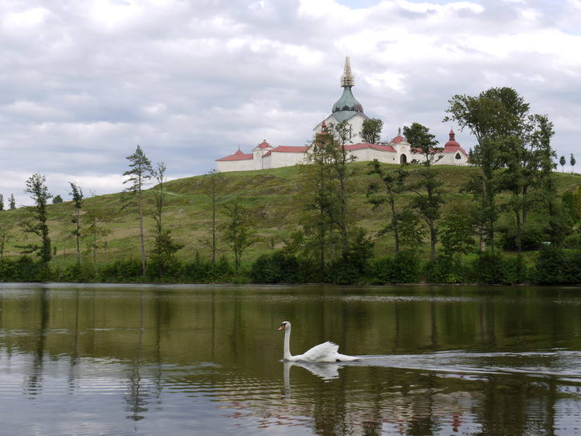

Outstanding Universal Value
Brief synthesis

The Pilgrimage Church of St. John of Nepomuk at Zelená hora is situated at Žďár nad Sázavou in western Moravia, in the Vysočina Region, Czech Republic. The church, which was built between 1719 and 1727, is dedicated to the cult of St. John of Nepomuk, a 14th century martyr canonised in the 18th century.
The property consists of a central-plan church surrounded by a circular cloister. It is one of the most original works by the prominent architect of the Baroque period, Jan Blažej Santini Aichel. The ensemble is an outstanding example of architecture of transition between the Gothic and the Baroque styles. The composition of the property is based on the aesthetic concept of a perfect central complex with an explicit central vertical dominant. The centrality of the design is accentuated by the ground plan, which is based on the parallel to two equivalent radials. The number 5, that is a reference to the five stars of the halo of St. John of Nepomuk representing the five virtues of the saint, is dominant in the layout and proportions. The star-shaped ground plan of the church, with five points, is defined by two groups of five radial axes upon which the basic elements of the ground plan and of the composition of the mass are organized. Ten radials, which intersect in the centre of the church itself, determine the arrangement of chapels and gates of the cloister that surrounds the pilgrims' field situated outside around the church that is situated in its centre. The chapels and the church portals are spanned by ribbed vaults with stucco decorations, inspired by late Gothic style. The influence of this period is also demonstrated by the presence of buttresses on the exterior walls and the pointed form of the windows and portals.
The main impression given by the interior is its loftiness and the upward orientation of the space. This space is divided into two by the conspicuous gallery at the base of the vaulting. The central space opens into five niches; of these, four are partitioned horizontally and the fifth, on the east, is filled by the main altar. The church retains many of its original furnishings, which include the main altar, designed by Santini and representing the celebration of St John of Nepomuk in heaven and the four side altars, also designed by Santini and depicting the four Evangelists.
Criterion (iv): The Church of St. John Nepomuk is an outstanding example of an architectural style that spanned the transition between the Gothic and Baroque traditions.

Integrity
All the key elements conveying the Outstanding Universal Value of the property are situated within its boundaries, i.e. the Baroque church, the surrounding pilgrims' field with the church in its centre and the cloister enclosing the ensemble. Since its completion, the basic structure of the church and cloister remained unchanged. The definition of the boundaries of the property and its area are appropriate. None of the attributes of the property is threatened and neither is its visibility in the picturesque landscape of its surroundings. The buffer zone is identical to the protective zone of the former Cistercian monastery and the area of pilgrims' church, which was designated in 1993 by the local authorities, and no changes to the land use plan are expected in the buffer zone.

Authenticity
The Church of St. John of Nepomuk, a pilgrimage site at Zelená Hora, meets the requirements of authenticity. Its architecture as a whole and in detail corresponds to the original design. The church was not changed significantly following the fire in 1784 that destroyed a part of the roof and of the facade, components that were rebuilt in 1792 and 1793, and between 1794 and 1802 respectively. Following the inscription of the property, maintenance and repair works have been done both in the interior and exterior of the property; it was carried out in accordance with strict international standards for heritage conservation and with the systematic use of historical materials and techniques. The property has retained its function as a place of worship. The cemetery located inside the cloister is still present. Some graves were moved. A complete restoration of the church is currently underway.

Protection and management requirements
The church is protected under Act No. 20/1987 Coll. on State Heritage Preservation as amended and it is designated a national cultural heritage site; it thus enjoys the highest degree of legal protection as regards heritage preservation. The buffer zone is identical to the protective zone of the former Cistercian monastery and the area of pilgrims' church, which has been defined to protect them in 1993.
The property has been managed by the National Heritage Institute, a state-funded institution which is responsible for the maintenance, protection and promotion of the property. The site has a Management Plan, which is scheduled for regular updates. The work on the property is funded by financial resources allocated from the budget of the institution and by special-purpose financial instruments, such as grant schemes and funding through the programme of the Ministry of Culture of the Czech Republic allocated to the maintenance and conservation of the immovable cultural heritage, as well as financial resources allocated from other public budgets. The church furniture is the property of the Roman Catholic parish of Žďár nad Sázavou which provides for its maintenance and protection.
In 2013, the Government of the Czech Republic passed a bill on restitution of church property, on the basis of which discussions are held at present whether the Pilgrimage Church of St John of Nepomuk at Zelená Hora will be returned to the Roman Catholic Church. After this issue is settled, it will be necessary to update the Management Plan with regard to the capabilities and intentions of the new owner. Currently, the issue remains open. (In this context it should be noted that even if the compound of the Pilgrimage Church of St John of Nepomuk at Zelená Hora is returned to the Roman Catholic Church, it will not cease to be a property enjoying the highest degree of protection under Czech law.)
Since 2000, annual monitoring reports have been prepared at the national level, to serve the World Heritage property manager, the Ministry of Culture, the National Heritage Institute and other agencies involved.

Litomyšl Castle
Litomyšl Castle was originally a Renaissance arcade-castle of the type first developed in Italy and then adopted and greatly developed in central Europe in the 16th century. Its design and decoration are particularly fine, including the later High-Baroque features added in the 18th century. It preserves intact the range of ancillary buildings associated with an aristocratic residence of this type.
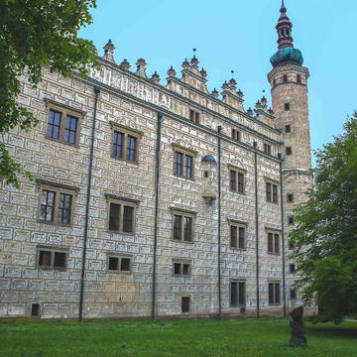
Brief Synthesis

The Litomyšl Castle is an outstanding example of an arcaded Renaissance country residence, a type of structure first invented in Italy and then developed in the Czech Lands to create a mature form with special architectural value. Situated at an important communications junction on the main route between Bohemia and Moravia, in the Pardubice region, Litomyšl was a fortified centre on the hill where the castle now stands.
The work on the Renaissance building began in 1568 under the supervision of Jan Baptista Avostalis (Giovanni Battista Avostalli), who was soon joined by his brother Oldřich (Ulrico). Most of the work had been completed by 1580. The castle interior underwent alterations between 1792 and 1796, based on the designs of Jan Kryštof Habich, but he was careful to preserve the fine building’s Renaissance appearance with impressive gables.
The castle is a four-winged, three-storeyed structure with an asymmetrical disposition. The western wing is the largest, whereas the southern wing is a two-storeyed arcaded gallery, closing the second square courtyard (a feature that is unique to Litomyšl). The groin-vaulted arcading continues around the western and eastern sides of the courtyard. The south-eastern corner of the eastern wing contains the castle chapel. One of the most striking features in the interior of the castle consists in the fine neoclassical theatre from 1796-97 in the western wing. The original painted decoration of the auditorium, stage decorations and stage machinery have survived intact. The house has richly decorated interiors, basically Renaissance in form and with lavish late Baroque or neoclassical ornamentation in the form of elaborate plasterwork and wall and ceiling paintings.
The buildings associated with the castle were all built or rebuilt during the course of the modifications that the castle itself underwent over time, and this is reflected in their architectural styles. Among the ancillary buildings, the most interesting is the Brewery, the birthplace of Bedřich Smetana, one of the greatest Czech composers of all time. It lies to the south of the first courtyard. Originally constructed to complement the castle, with Renaissance sgraffito decoration, it was remodelled by the well-known architect František Maximilián Kaňka after the 1728 fire and received what is its present appearance. The ensemble also includes the former French formal garden with its saletta (pavilion) in the Baroque style and an 18th-century English-style park.
Criterion (ii): Litomyšl Castle is an outstanding and immaculately preserved example of the arcaded castle, a type of building first developed in Italy and modified in the Czech Lands to create an evolved form of special architectural quality.
Criterion (iv): Litomyšl Castle illustrates in an exceptional way the aristocratic residences of central Europe in the Renaissance and their subsequent development under the influence of new artistic movements.

Integrity
All the key elements which the outstanding universal value of the property is based upon, e.g. the former aristocratic residence, the garden, the entrance courtyard and the outbuildings, are located within its boundaries. Its delimitation and size are appropriate. None of the physical attributes of the property are under threat. The castle has retained all of its original features (the integrity of the ensemble and the ground plan of the main building), its high artistic quality (the formal logic of the three-storeyed arcaded galleries, the scenic sgraffiti, the “Late Baroque Classical” interior decoration) and the relation of the ensemble to its urban setting. The vistas have also been preserved. The buffer zone is delimited; it consists of a declared urban heritage reservation and its protective zone, which both have stabilized urban structures.

Authenticity
The authenticity of the property is high. The individual components remain physically integrated with one another in their original state, whilst the complex retains its spatial relationship with its historic urban setting. The successive modifications and conservation works that have taken place over several hundred years have been respected. No attempt has been made to select a particular period to display, but instead the organic evolution is presented in its entirety. The current form and appearance, including the floors with open Renaissance arcades in the courtyard and sgraffito decorations on the facades and on the gables, are defined by the original design. Restoration works have been performed using the materials and historical techniques that complied with international standards for heritage conservation.

Protection and management requirements
The property is protected under Act No. 20/1987 Coll. on State Heritage Preservation as amended as a designated national cultural heritage site. It thus enjoys the highest degree of legal protection. The buffer zone of the property consists of the historic centre of the town, which is designated as an urban heritage reservation and has a protective zone itself. On the territory of the property and of its buffer zone, no change in the urban area is planned.
Sustainable use of ancillary buildings is the main goal of the completed Castle Hill Revitalization project, which also includes some contemporary, however reversible, architectural interventions within the property. Key long-term issues of the main castle building (inadequate use or incipient deterioration of particular parts) are being addressed by newly drafted project reflecting also Castle Hill Revitalization experience.
The responsibility for the property management is shared by the state through National Heritage Institute and the City of Litomyšl, which are responsible for the maintenance, protection and promotion of the property. The management plan of the property is under preparation. Financial instruments for the conservation of the property include grant schemes and funding through the programme of the Ministry of Culture of the Czech Republic allocated to the maintenance and conservation of the immovable cultural heritage, as well as financial resources allocated from other public budgets. Maintenance of the property is carried out in accordance with a planned schedule.
Since 2000, annual monitoring reports have been prepared at the national level to serve the World Heritage site manager, the Ministry of Culture, the National Heritage Institute and other agencies involved.

Lednice-Valtice Cultural Landscape
Between the 17th and 20th centuries, the ruling dukes of Liechtenstein transformed their domains in southern Moravia into a striking landscape. It married Baroque architecture (mainly the work of Johann Bernhard Fischer von Erlach) and the classical and neo-Gothic style of the castles of Lednice and Valtice with countryside fashioned according to English romantic principles of landscape architecture. At 200 km² , it is one of the largest artificial landscapes in Europe.

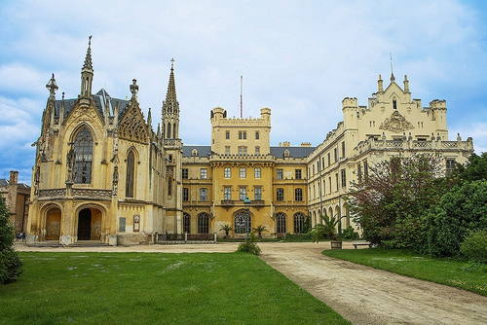

Outstanding Universal Value
Brief synthesis

The Lednice-Valtice valley is located in South Moravia, Czech Republic. With its 143 km2, the Lednice-Valtice Cultural Landscape is unique because of how architectural, biological and landscape features have been shaped over time.
The Liechtenstein family came first to Lednice in the mid-13th century, and by the end of the 14th century they had also acquired Valtice, nearby. These properties were to become the nucleus of the family's extensive possessions. The two estates were later joined with the neighbouring Břeclav estate to form an organic whole, to serve the recreational requirements of the ducal family and as material evidence of its prestige. The execution of this grandiose design began in the 17th century with the creation of avenues connecting Valtice with other parts of the estate. It continued throughout the 18th century with the construction of a network of paths and scenic trails, imposing order on nature in the manner of the English artists and architects of the Renaissance. The early years of the 19th century saw the application by Duke Jan Josef I of the English concept of landscaped designed park, strongly influenced by the work of Lancelot “Capability” Brown at Stowe and elsewhere in England. Enormous landscaping projects were undertaken, which included the raising of the level of the Lednice Park and the digging of a new channel for the Dyje River. Smaller parks designed based on the English pattern, the so-called Englische Anlagen, were also created around three large ponds.
The composition of the landscape is based on the two country houses, Lednice and Valtice. The Valtice country house has medieval foundations, but it underwent successive remodelling in Renaissance, Mannerist and, most significantly, Baroque styles. Its present Baroque appearance is due to several architects, notably Johann Bernard Fischer von Erlach, Domenico Martinelli and Anton Johann Ospel. Along with the Baroque Church of the Assumption of the Virgin Mary, it is the dominant feature in the system of avenues created in the 17th and 18th centuries. The Lednice country house began as a Renaissance villa of around 1570, and then was progressively changed and remodelled to reflect Baroque, Classical and Neo-Gothic fashions. It was the 1850 Gothic Revival remodelling that brought it into harmony with the prevailing Romanticism of this part of the landscape. The park of the Lednice country house includes architectural objects like a remarkable Palm house, a unique Minaret and other minor structures.
Taking the property as a whole, it is the mingling and interplay of Baroque and Romantic elements that gives it a special character: architecture and landscape are intimately associated with one another. All the buildings are sited with great care at high points, as in the case of the Kolonáda (Colonade), the Rendezvous, Rybniční zámeček (Fishpond Manor) or Pohansko, at the crossing of major routes (the Obelisk), or at the boundary between Moravia and Lower Austria (Hraniční zámeček). The view and vistas are also mutually linked. Most have views of the two dominant features, the Minaret and the Kolonáda, but there are also significant visual connections between other groups (the Temple of Apollo, Belvedere, Janohrad, the Hunting House, the New Farmyard, the Fishpond Manor, the Temple of Three Graces, the Obelisk and St. Hubert Chapel etc.).
An important element in the appearance of this entire area is the very wide range of native and exotic tree species and the planting strategy adopted. The greatest variety is to be found in the parklands which cluster around the two main residences and along the banks of the fishponds between Lednice and Valtice. The Pohansko Manor is built on the site of an important hillfort of the Great Moravian period dating from the 8th century. The 2 km of massive ramparts enclosing an area of 28 ha are still visible. Excavations have revealed the court of the ruler, a church (the plan of which is preserved in situ), several substantial houses and a rich burial ground.
The Lednice-Valtice Cultural Landscape is an exceptional example of a designed cultural landscape, which is made particularly impressive by the number and variety of cultural and natural elements that it contains.

Criterion (i): The Lednice-Valtice Cultural Landscape is an outstanding artistic creation that succeeds in bringing together in harmony cultural monuments from successive periods and both indigenous and exotic natural elements to create an outstanding work of human creativity.

Criterion (ii): By combining the Baroque, Classical and Neo-Gothic architectural styles and by transforming the landscape according to the English romantic principles, Lednice-Valtice estate served as a model throughout the Danube region.

Criterion (iv): The Lednice-Valtice Cultural Landscape is an outstanding example of a cultural landscape designed and created intentionally by a single family during the century of Enlightenment, the Romantic period and later on.

Integrity
The property includes the territory of the former estate of the Liechtenstein family. Its size and delimitation are appropriate. All the key elements conveying the Outstanding Universal Value of the property are situated within its boundaries. There is no buffer zone due to the characteristics of the site. Although the most important elements necessary to convey the Outstanding Universal Value are contained inside the property boundaries, there is a need to protect the key viewpoints outside the boundaries. Because of this fact and the proximity of the town Břeclav and of other villages, a buffer zone may be proposed in the future to keep the visual integrity. The property has a stabilized landscape planning; however, there is a risk of disharmonious development (e.g. transport, urban). Nature conservation organisations exert some pressure on the site that infringes the preservation of the original compound of the landscape and of the woody plants.

Authenticity
The Lednice-Valtice Cultural Landscape is of high authenticity concerning its present form and appearance, which conform closely with the ideas of successive owners over several centuries. The landscape has continued to evolve according to the original planning principles. The prince's country houses serve as architectural museums; their interiors are well maintained and open to the public. All buildings are restored using original materials and techniques. Exotic tree species planted on the grounds come, to a large extent, from seedlings and seeds imported from North America at the beginning of the 19th century. They have been regularly maintained. Plants in the unique Palm house in Lednice are cultivated using traditional methods, with manual labour playing a considerable role.

Protection and management requirements
The Lednice-Valtice Cultural Landscape is protected by Act No. 20/1987 Coll. on State Heritage Preservation as amended. The property is designated a protected cultural landscape. The Lednice and Valtice country houses are designated national cultural heritage sites. The property does not have a buffer zone due to the characteristics of the site but it is neighbouring the Pálava Landscape Protected Area declared by UNESCO in 2003. The Municipal Offices of Valtice, Břeclav, Lednice, Podivín, Hlohovec, the District Office of Břeclav and the Regional Office of the South Moravia Region share responsibility for the preservation of cultural landscape under the overall supervision of the Ministry of Culture. The pressure of development (e.g. transport, urban) is regulated by the Act mentioned above and by the valid land use plans with respect to the visual integrity of the property. So, any actions that might affect the property must be authorized by the appropriate state agencies and regional offices. Nevertheless, a buffer zone may be proposed in the future to keep the visual integrity of the property.
The property management is by an inter-branch steering group. The Management Plan is in place and regular updates are planned. The property management is provided by several stakeholders on the national, regional and local levels. There is a need to reinforce the role and involvement of the local communities as well as to make sure that the property is managed in accordance with sustainability. A suitable solution would be to develop a site management system (coordinator), including a legally based competence platform, to provide on principles of the participatory management and subsidiarity a conceptual, as well as daily co-ordination of interdisciplinary interests relating to the preservation of values of the whole property.
The state-funded institution National Heritage Institute provides finances for maintenance and conservation of both country houses, their grounds and along with some minor structures forming the composition of the property. Due to the property extent and the complex structure of ownership inside the property, individual maintenance schedules have been set. Financial instruments for the conservation of the property include grant schemes and funding through the programme of the Ministry of Culture of the Czech Republic allocated to the maintenance and conservation of the immovable cultural heritage and as well as financial resources allocated from other public budgets. Municipal funds, funds from private institutions and collaborating agencies also contribute to the conservation of the property.
Since 2000, annual monitoring reports have been prepared at the national level to serve the World Heritage property manager, the Ministry of Culture, the National Heritage Institute and other agencies involved.

Kutná Hora: Historical Town Centre with the Church of St Barbara and the Cathedral of Our Lady at Sedlec
Kutná Hora developed as a result of the exploitation of the silver mines. In the 14th century it became a royal city endowed with monuments that symbolized its prosperity. The Church of St Barbara, a jewel of the late Gothic period, and the Cathedral of Our Lady at Sedlec, which was restored in line with the Baroque taste of the early 18th century, were to influence the architecture of central Europe. These masterpieces today form part of a well-preserved medieval urban fabric with some particularly fine private dwellings.

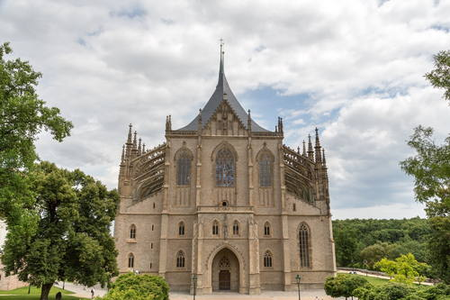

Outstanding Universal Value
Brief synthesis

The historic town centre of Kutná Hora with the Church of St Barbara and the Church of Our Lady at Sedlec are located in Central Bohemian Region of the Czech Republic. Kutná Hora has developed as a result of the discovery and exploitation of the rich veins of silver ore since the end of the 13th century. In the 14th century, it became a royal city endowed with buildings that symbolized its enormous prosperity. The Church of St Barbara and the former Cistercian monastery church of Our Lady and St. John the Baptist in Sedlec, located at a distance of approximately 1.5 km to the north-east of the historic centre, were to influence considerably the architecture of Central Europe. Today, these masterpieces, representing cathedral architecture, form the dominants of a well-preserved medieval town-planning structure filled with Gothic and Baroque urban fabric.
The most striking of Kutná Hora is the church of Saint Barbara, the Gothic jewel whose interior is decorated with frescoes depicting the secular life of the medieval mining town of Kutná Hora. This piece of art had a major influence on the architecture of central Europe. The former Cistercian cathedral, Our Lady of Sedlec, which is at a distance of 1.5 km northeast of the historic centre, was restored in the Baroque style in the early 18th century by Jan Blazej Santini. For the first time, he used his conception of the Baroque Gothic style which strongly influenced the history of architecture.
The oldest neighbourhoods Vlassky dvur (Italian courtyard which includes the southeast tower) are dating back to the early 14th century. The royal chapel is Gothic and boasts a remarkable interior design. Attached to the Italian court, we find the church of St Jacob from the 14th century whose furniture date back mostly to the end of the Gothic period. The Hradek (little castle) is an interesting example of Gothic palazzetto of Central Europe which has kept both inside and outside in its original condition.
Throughout its extensive area, the historic centre of Kutná Hora reflects a very specific medieval structure of the city ground plan, which is determined by mining, later with only isolated partial corrections. In spite of its long dynamic development, the town retains an earlier pattern of communications predating the city's actual origin. Moreover, the historic built-up area, formed by the finest architectural works from Gothic and Baroque periods and the specific breathtaking Kutná Hora panorama, is impressively linked to a picturesque surrounding landscape.

Criterion (ii): The urban fabric of Kutná Hora was endowed with many buildings of high architectural and artistic quality, notably the Church St Barbara, which had a profound influence on subsequent developments in the architecture of Central Europe.

Criterion (iv): The historic town centre of Kutná Hora, with the Church of St Barbara and the Church of Our Lady at Sedlec, constitutes an outstanding example of a medieval town whose wealth and prosperity was based on its silver mines.

Integrity
All key elements defining the Outstanding Universal Value of the property are situated within the inscribed area. The property is also protected by a buffer zone that is clearly defined and adequate. Since the inscription of the property on the World Heritage List, no significant changes have been made within its perimeter, and there are no planned modifications for the future. So far, minor changes that have been carried out on the housing stock had neither a significant influence on its character, nor any significant impact on the urban fabric and the overall layout of the town. Nevertheless, increasing pressure to develop the attics of the houses or to add floors might have a negative impact on the visual integrity of the roofscape of the town, which is very well preserved. However, these risks are kept under control by the state heritage preservation authority. There will obviously be, in the future, partial building arrangements without significant impact on the overall character and urban structure of the town.

Authenticity
The property is of high authenticity; it is a proof that the original ground plan organism developed as a result of the exploitation of the silver mines. Very few of the old fortifications have survived; as regards the rest of the historic town centre, the richness of private homes is of major interest. Most of the urban fabric is intact and preserves the evidence of its organic development. Individual buildings survive with a remarkable authenticity degree of design and materials. The facades of a number of houses feature numerous Gothic elements, while others reflect an inclination to the Baroque and to the 18th century. Nevertheless, the structures of these houses are, on the whole, medieval as confirmed by a detailed scientific study that uncovered cellars with barrel vaults and lower floors in Gothic style. The authenticity of the ensemble, of the town layout and the architectural Kutná Hora features are attested by the systematic surveys that have been carried out since the end of the Second World War. The future of this level of authenticity is assured by the provisions of legislation which have strict standards designed to ensure the respect for authenticity.
Conservation works are being carried out in accordance with strict internationally recognized conservation criteria and with consistent use of historical materials and technological procedures.

Protection and management requirements
The property is protected by the Act No. 20/1987 col., on State Heritage Preservation, as amended. Under this Act, the historic centre of Kutná Hora is an urban heritage reservation, in the territory of which also the Church of St. Barbara is situated. In accordance with the existing legislation, the protective zone of the urban heritage reservation is identical with the buffer zone of the historic centre of Kutná Hora. The Church of Our Lady at Sedlec is situated within this protective zone. Hence both component parts of the property have the common buffer zone. The Church of Our Lady at Sedlec is designated, under the Act mentioned above, a cultural heritage site.
Under the law mentioned above, the Church of St Barbarba is classified as a national cultural monument and as such it has the highest level of heritage protection at the expense of the state. The Italian Court (the former royal palace with the Mint) has the same level of protection. The Cathedral of Our Lady at Sedlec is, under the law mentioned above, classified as a cultural monument, as well as most other historic buildings in the historic centre of Kutná Hora.
The responsibility for the property management is shared between the Roman Catholic Church and the City of Kutná Hora, which are responsible for the maintenance, conservation and presentation of the property. Any actions that might affect it must be authorized by the appropriate state or local authorities.
The rehabilitation of the property is carried out with the support of public funding; for example the city has a good quality Programme for the Regeneration of Urban Heritage Reservations and Zones.
The Management Plan of the property, which is coordinated by the Municipality of Kutná Hora, is in place and is scheduled to be updated regularly. Due to the extent of the property and the complicated structure of ownership inside the property, maintenance and conservation works is subject to individual programmes that are coherent with the Programme for the Regeneration of Urban Heritage Reservations and Zones.
Financial instruments for the conservation of the property mainly include grant schemes and funding through the programme of the Ministry of Culture of the Czech Republic allocated to the maintenance and conservation of the immovable cultural heritage and of areas under heritage preservation, as well as financial resources allocated from other public budgets.
Since 2000, annual monitoring reports have been prepared at the national level to serve the World Heritage property manager, the Ministry of Culture, the National Heritage Institute and other agencies involved.

Jewish Quarter and St Procopius' Basilica in Třebíč
The ensemble of the Jewish Quarter, the old Jewish cemetery and the Basilica of St Procopius in Třebíč are reminders of the co-existence of Jewish and Christian cultures from the Middle Ages to the 20th century. The Jewish Quarter bears outstanding testimony to the different aspects of the life of this community. St Procopius' Basilica, built as part of the Benedictine monastery in the early 13th century, is a remarkable example of the influence of Western European architectural heritage in this region.

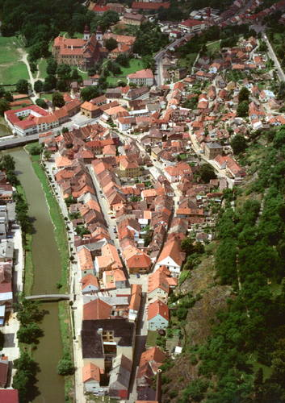

Outstanding Universal Value
Brief synthesis

The property includes the Jewish Quarter (former ghetto), the Jewish Cemetery and the St. Procopius' Basilica. It is situated in the town of Třebíč, located in the Vysočina Region, in western Moravia, Czech Republic. The ensemble provides an exceptional testimony to the peaceful coexistence of Jewish and Christian communities and cultures from the Middle Ages up to World War II.
The Jewish Quarter grew spontaneously along the Jihlava River. It bears witness to various aspects of the life of this community forced to live in limited space due to political constraints. The Jewish Quarter has retained its original street plan, its typical spatial arrangement, as well as its social functions, such as the synagogues and the schools, as well as a former leather factory.
A typical building of this quarter is distinguished by a condominium structure, a highly complex form and diversity of style. On the street level, there was often a shop or a workshop; the upper levels were reserved for residential use. A wide range of historic details has been preserved, such as the types of roofing, the architectural expression of the facades and some original interiors (vaulted ground floors, one or two upper floors with wooden ceilings).
St. Procopius Basilica is situated on a hill overlooking the Jewish Quarter. It was built in the early 13th century, and originally, it was a part of a Benedictine monastery that was replaced in the 16th century by a palace to which it is connected. St. Procopius Basilica is one of the first examples of the influence of Western architecture in Central Europe.
The Jewish cemetery lies outside the Jewish Quarter, behind the hill. It has two parts, the first part dates from the 15th century, and the second from the 19th century. There are some 4,000 tomb stones; some carvings are important.

Criterion (ii): The Jewish Quarter and St. Procopius Basilica of Třebíč bear witness to the coexistence of and interchange of values between two different cultures, Jewish and Christian, over many centuries.

Criterion (iii): The Jewish Quarter of Třebíč is an exceptional testimony to the cultural traditions related to the Jewish diaspora in central Europe.

Integrity
All key elements conveying the Outstanding Universal Value of the property are situated within its boundaries. The definition of the boundaries and the size are appropriate. In the Jewish Quarter, the works done on the buildings had no significant negative impact on their form and character, and no impact on the urban structure. The visual integrity is not threatened, and the spatial and visual relationship between the Jewish Quarter, the Basilica and other historical quarters of the town of Třebíč, situated outside the boundaries of the property, has been preserved. In the buffer zone, new construction and remodelling are regulated in order to preserve the visual integrity of the property.

Authenticity
The ensemble that includes the Jewish Quarter, the Jewish Cemetery and St. Procopius Basilica has a high level of authenticity. The urban fabric of the Jewish Quarter has retained an exceptionally good stratification ranging from the late Middle Ages to the 20th century. Often, in one building, there can be parts that relate to several eras. The vernacular housing stock has been very well preserved; of 121 buildings that were there originally, only 5 were demolished. The individual buildings and the townscape have preserved the authenticity of materials, structures and simple decoration. Many interiors are intact and have a high level of authenticity. Restoration works are carried out in compliance with international standards for heritage conservation, using only historical materials and techniques. The cemetery includes a large number of tomb stones, both from the past centuries and contemporary. The Basilica has retained its historical character and authenticity, despite the various restorations it has undergone during its history.

Protection and management requirements
The property is protected under Act No. 20/1987 Coll. on State Heritage Preservation as amended, since it is located within the urban heritage zone. The buffer zone of the Jewish Quarter and of the St. Procopius Basilica is also located within the urban heritage zone of Třebíč, which moreover has its own protective zone, serving also as a buffer zone of the Jewish cemetery. St. Procopius Basilica and the Jewish Cemetery are designated as national cultural heritage sites, thus enjoying the highest degree of legal protection as regards heritage preservation. A number of buildings of the Jewish Quarter are designated as cultural heritage sites and also enjoy protection related to heritage preservation. The urban heritage zone and its protective zone have a stabilised spatial organisation where no changes are planned.
The property is managed by the town of Třebíč (the Jewish Quarter and the Jewish Cemetery) in cooperation with the Jewish Community of Brno (the synagogues and the cemetery) and the Parish Administration of the Roman Catholic Church (St. Procopius Basilica). The Management Plan of the property is in effect and is scheduled for regular updates. Because of the size of the property and of a complex ownership structure, individual maintenance schedules have been set. Financial instruments for the maintenance and conservation of the heritage sites that are part of the property namely include grant schemes and funding through the programme of the Ministry of Culture of the Czech Republic allocated to the maintenance and conservation rehabilitation of the immovable cultural heritage, as well as financial resources allocated from other public budgets.
From the point of view of heritage preservation, the property is in good state of repair and is subject to regular maintenance. Since its inscription on the World Heritage List, annual monitoring reports have been prepared at the national level to serve the World Heritage property manager, the Ministry of Culture, the National Heritage Institute and other agencies involved.

Holy Trinity Column in Olomouc
This memorial column, erected in the early years of the 18th century, is the most outstanding example of a type of monument specific to central Europe. In the characteristic regional style known as Olomouc Baroque and rising to a height of 35 m, it is decorated with many fine religious sculptures, the work of the distinguished Moravian artist Ondrej Zahner.

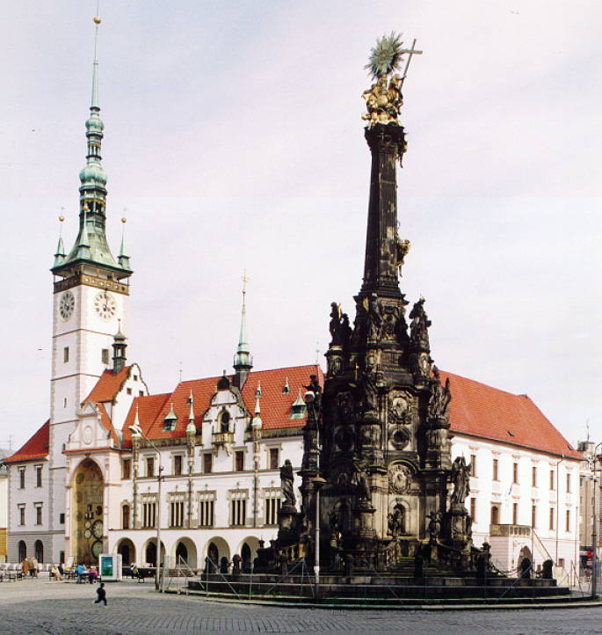

Outstanding Universal Value
Brief synthesis

The Holy Trinity Column is at the heart of the historic centre of the town of Olomouc, located in Central Moravia, Czech Republic. This memorial column is the most outstanding example of the Moravian Baroque style that developed in the 18th century in Central Europe. It has a high symbolic value as it represents the religious devotion and the sense of pride of the inhabitants of this city, to which it owes its existence. The Holy Trinity Column is, moreover, an exceptional example of this type of commemorative column, characteristic of Central Europe in the Baroque period. In terms of design, it is, no doubt, the most original work of its creator, Václav Render, whose amazing initiative, accompanied by generous financial support, made the erection of this monument possible.
The main motif of this work consists in the celebration of the church and of the faith that is linked, in quite a unique way, with the reality of a work of monumental art, combining architectural and town-planning solutions with elaborate sculptural decoration. The monument is built in the characteristic regional style known as the Olomouc Baroque, and it rises to a height 32.2 m above a ground plan with a round shape and a diameter of 17 m. The column is decorated with a number of high-quality sculptures representing religious themes, the work of the distinguished Moravian artist Ondřej Zahner (Andreas Zahner) and other Moravian artists (goldsmith Šimon Forstner among others). The Olomouc Holy Trinity Column is without equal in any other town, by virtue of its monumental dimensions, the extraordinary richness of its sculptural decoration, and the overall artistic execution. By the incorporation of a chapel in the body of the column and by the combination of the materials used, the Holy Trinity Column is quite exceptional.
Criterion (i): The Olomouc Holy Trinity Column is one of the most exceptional examples of the apogee of Central European Baroque artistic expression.
Criterion (iv): The Holy Trinity Column constitutes a unique material demonstration of religious faith in Central Europe during the Baroque period, and the Olomouc example represents its most outstanding expression.

Integrity
All the key elements that convey the Outstanding Universal Value of the property are situated within its boundaries, which correspond with the monument itself. The visual integrity of the property is not threatened since its buffer zone is identical with the urban heritage reservation, which enjoys special protection as a protected conservation area. Its town-planning structure is stable and no change that could threaten the integrity of the World Heritage property is planned.

Authenticity
The Holy Trinity Column in Olomouc is of high authenticity. Its present form and appearance closely reflect the original design and, since then, the column has not undergone any alterations. Since its completion, the awareness of the Column’s uniqueness has traditionally commanded the respect of the city authorities, its inhabitants as well as visitors.
Regular restoration and conservation works of the monument have been carried out for over two centuries, but were mainly limited to minor repairs and gilding. The preservation of authenticity has always been a major criterion for all these interventions. In the past, just one statue has been replaced by its exact replica in stone, that of a torch-bearer situated in the lower part of the column, which was damaged in the fighting at the end of World War II. Between 1999 and 2001, comprehensive restoration works have been carried out under close supervision of authorities responsible of state heritage preservation. To compensate for any loss of authenticity due to natural deterioration of the substrate of the monument, preventive conservation measures are taken.

Protection and management requirements
The Holy Trinity Column in Olomouc is subject to protection under Act No. 20/1987 Coll. on State Heritage Preservation as amended. According to this law, it is designated a national cultural heritage site and therefore it enjoys the highest degree of legal protection that is available under Czech law. The historic centre of the town, designated as an urban heritage reservation itself, is identical with the buffer zone of the property.
Financial instruments for the maintenance and conservation of the property mainly include grant schemes, funding through the programme of the Ministry of Culture of the Czech Republic allocated to the maintenance and conservation of the immovable cultural heritage, as well as financial resources allocated from other public budgets.
The City of Olomouc is the owner and manager of the Holy Trinity Column, and it provides for the maintenance and protection of the property. The property has a management plan which is scheduled for regular updates. There also exists a Land Use Plan of the City of Olomouc and a detailed zoning plan of the urban heritage reservation. These documents include special provisions to preserve and improve the historic townscape, with an emphasis on the importance of preserving open spaces around the monument.
Since inscription of the property on the World Heritage List, annual monitoring reports have been prepared at the national level to serve the World Heritage property manager, the Ministry of Culture, the National Heritage Institute and other agencies involved.

Holašovice Historic Village
Holašovice is an exceptionally complete and well-preserved example of a traditional central European village. It has a large number of outstanding 18th- and 19th-century vernacular buildings in a style known as 'South Bohemian folk Baroque', and preserves a ground plan dating from the Middle Ages.

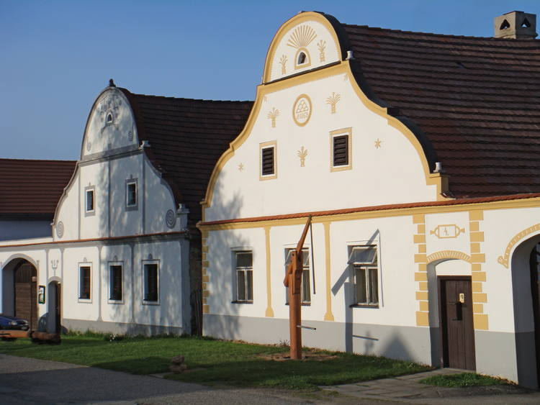

Outstanding Universal Value
Brief synthesis
The Holašovice Historical Village is situated in the South Bohemian Region of the Czech Republic, 17 km west of České Budějovice and 24 km north of Český Krumlov.
The village includes twenty-three farmsteads which are placed around a rectangular village green, with the chapel of St. John of Nepomuk, a cross, a forge and a small fish-pond.
Holašovice is an exceptionally complete and well preserved example of a traditional central European village, containing a number of high-quality vernacular buildings from the 18th and 19th centuries.
Almost all the farms are built according to the same pattern; usually, they are U-shaped with a farmyard in the middle. The gables facing the village green and their stucco decoration are in a style known as South Bohemian “Folk Baroque”. Almost always, they feature the year of foundation of the house as well as some decorative elements; all of it is painted in a variety of colours. In fact, on the facades, Holašovice master-builders replicated decorations inspired by manorial buildings of Bohemia and Austria. In addition to large farmsteads, the Holašovice Historic Village includes several farming houses which are much smaller.
The small chapel of St. John of Nepomuk features a high bell-shaped facade. It has a gable roof and a hip roof on one side, as well as a lantern-turret on four pillars with a bell. The interior is vaulted and closed by two lunettes. The village forge and the blacksmith's house are single-storey buildings with a gable roof. The forge features a typical arched opening overlooking the village green (now closed since the building is presently inhabited).

Criterion (ii): Holašovice is of special significance in that it represents the fusion of two vernacular building traditions to create an exceptional and enduring style, known as South Bohemian “Folk Baroque”.

Criterion (iv): The exceptional completeness and excellent preservation of Holašovice and its buildings make it an outstanding example of traditional rural settlement in central Europe.

Integrity
All the key elements which the Outstanding Universal Value of the Holašovice Historic Village is based upon are situated within its boundaries. The boundaries and the size of the property are appropriate. The historic village has a stabilised structure inside which no change is planned. Partial improvements that have been made in various buildings have had only small impact on them. As regards to the volumes and details of the new buildings, there was a consistent respect for tradition. No planned pressure exists concerning new constructions that could jeopardize the visual integrity of the conservation area, within its boundaries. The buffer zone is delimited but subject to threats coming from potential urban development that might have a serious impact on the visual context of the property and that could also jeopardize the visual integrity of the protected area as a whole.

Authenticity
The village of Holašovice is a perfectly preserved and exceptionally complete example of a central European village built on a traditional ground that includes a large number of 18th and 19th century highly valuable vernacular buildings. The village has kept its original medieval layout, land parcelling and its historical appearance. Hence, the authenticity of the layout and of the land parcelling of the village, which have been stabilized in the 19th century, is very high. This assertion is documented by the early maps produced by cadastral surveys.
A number of the individual farmsteads have preserved a substantial measure of authenticity in their internal layouts and external features. However, others have undergone radical changes, especially to their interiors, which have severely reduced their overall authenticity; this is especially applicable to the buildings used as retirement homes.

Protection and management requirements
The Holašovice Historic Village is designated a village heritage reservation under Act No. 20/1987 Coll. on State Heritage Preservation as amended. Twenty-one farmsteads around the central village green and the forge and the blacksmith's house in the centre of the village green are designated cultural heritage assets and protected under the Act mentioned above.
Most buildings that are part of the property are privately owned. In municipal ownership there are: farmstead No 18 (village pub), the forge and the blacksmith's house No 23 and house No 43), the chapel and other religious objects (crosses, sanctuaries).
The management plan of the property is in effect and is updated regularly. The property management is a responsibility of the municipality of Jankov whose administrative powers cover Holašovice. This municipality provides the maintenance, functioning and development of the property. Because of the size of the site and of the complex structure of the properties, individual maintenance schedules have been set.
The buffer zone has been defined in accordance with applicable regulations. It is identical to the protective zone of the village heritage reservation. However, the potential urban development might have an impact on the visual context of the property with the surrounding landscape. Several measures, which are integrated in the actual development plan, were taken to mitigate this risk. Precondition for new construction in major development areas is the establishment of regulatory plans, zoning plans and studies, which will determine detailed regulations in these localities.
Financial instruments for the conservation of the property namely include grant schemes and funding through the programme of the Ministry of Culture of the Czech Republic allocated to the maintenance and conservation of the immovable cultural heritage, as well as financial resources allocated from other public budgets.
Since 2000, annual monitoring reports have been prepared at the national level to serve World Heritage property manager, the Ministry of Culture, the National Heritage Institute and other agencies involved.

Historic Centre of Telč
The houses in Telc, which stands on a hilltop, were originally built of wood. After a fire in the late 14th century, the town was rebuilt in stone, surrounded by walls and further strengthened by a network of artificial ponds. The town's Gothic castle was reconstructed in High Gothic style in the late 15th century.

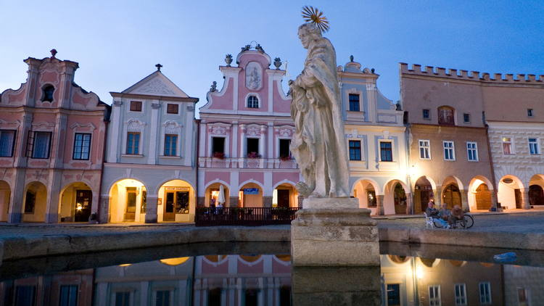

Outstanding Universal Value
Brief synthesis
The town of Telč is located near the southwestern border between Moravia and Bohemia, in the Vysočina Region of the Czech Republic. It is situated in a region which was thickly forested until the 13th century. The property consists of the historic town centre, with the castle situated in the middle, and of two bodies of water, originally having a defensive function.
The origins of the settlement are unclear: there was an early medieval settlement at Staré Město to the south-east of the present town, but there is no mention of Telč in documentary records before 1333-1335, when reference is made to the existence there of an important castle (and presumably also a church and settlement). The town of Telč, whose area covers 36 ha, was probably founded in the mid 14th century. The town itself is of special importance since it was founded on purpose to gain political and economic control over an area where there were deep forests in the 13th and 14th centuries.
The outstanding nature of Telč, in terms of the quality and authenticity of its cultural elements, the tangible evidence of its origins and evolution represented by its original layout and architecture, and its picturesque setting is unquestionable. The Renaissance castle forms the centre of the city. It is a major component of the urban townscape and it retains obvious traces of its Gothic precursor. The castle represents a unique authentic complex with its original material substance and decorations. Its original interior is imbued with Italian art.
The Historic Centre of Telč features a triangular market square surrounded by Renaissance and Baroque burgher houses (but whose origins are medieval). These houses are linked by a continuous arcade. Their facades are characterized by a great diversity as regards the choice of decorative elements. In the middle of the market square, there is a fountain and a plague column. A little further, there is the town hall, the Church of the Holy Spirit, the Jesuit College and the Gothic St. James parish church. Finally, the evidence of the origins and historical development of the city is provided by the city walls built of stone whose functioning was enhanced by a system of fishponds, originally built for its strategic security.

Criterion (i): Telč is an architectural and artistic ensemble of outstanding quality. Its triangular market place possesses great beauty and harmony as well as great cultural importance surrounded as it is by intact and well preserved Renaissance buildings with a dazzling variety of facades.

Criterion (iv): The later Middle Ages in Central Europe saw the “plantation” of planned settlements in areas of virgin forest for reasons of political control and economic expansion. Telč is the best surviving example.

Integrity
All the key elements necessary to convey the Outstanding Universal Value of the property are situated inside the inscribed area. Its delimitation and size are appropriate. The buffer zone of the Historic Centre of Telč is delimited too; its boundaries are identical to the boundaries of the protective zone of the urban heritage reservation. The urban fabric of the property and its buffer zone is dense, and its spatial organization is stabilised. No change is expected in the spatial development of the territory. So far, minor improvements of the buildings that have been carried out had no important negative impact either on their character or on the overall layout of the town. Nevertheless, the increasing development pressure on the roofscape might have a negative impact on the visual integrity of the town, which is very well preserved. However, these risks are kept under proper control by heritage preservation authorities and by the fact that the seat of the Regional Department of the National Heritage Institute is situated specifically in Telč.

Authenticity
The Historic Centre of Telč is of high authenticity because it escaped the mania for over-restoration of the 19th century. So, both the individual buildings and the townscape have been preserved; the same applies to the authenticity of materials and designs in their historical evolution. Restoration work is carried out in compliance with the international standards for heritage preservation and historical materials and techniques are used.

Protection and management requirements
The property is protected by Act No. 20/1987 Coll. on State Heritage Preservation as amended and is designated as urban heritage reservation. The castle has been designated a national cultural heritage site, hence it enjoys the highest degree of legal protection with regard to heritage preservation. A number of other buildings situated within the boundaries of the property are designated cultural heritage sites. The buffer zone of the property is identical to the protective zone of the urban heritage reservation. In the long term, risks related to the development will have to be taken into account and building regulations will need to be strengthened. There is increased pressure for transforming attic spaces (loft) into living spaces. Therefore it is necessary to correct any loft, not to disturb the roofscape. Loft conversions are not permitted in the event that the truss structure is historically valuable and worthwhile to be preserved. In the case of authorized loft, a concerned authority has control over the number, size, location and shape of roof lights.
The property Management Plan is currently in the process of finalisation. The responsibility for the property management is shared by the National Heritage Institute, a state-funded institution which is responsible for maintenance, conservation, functioning and development of the Renaissance castle, and of the Municipality of Telč which is in charge of the maintenance, conservation, functioning and development of the remaining part of the property. Due to the extent of the property and its complicated ownership structure, maintenance and restoration of the various properties are subject to individual programmes that are coherent with the Programme for the Regeneration of Urban Heritage Reservations and Zones. Financial instruments for the conservation of the property mainly include grant schemes, funding through the programme of the Ministry of Culture of the Czech Republic allocated to the maintenance and conservation regeneration of the immovable cultural heritage and of areas under heritage preservation, as well as financial resources allocated from other public budgets.
The property is in good condition and is subject to regular maintenance. Since 2000, annual monitoring reports have been prepared at the national level to serve the World Heritage property manager, the Ministry of Culture, the National Heritage Institute and other agencies involved.

Historic Centre of Český Krumlov
Situated on the banks of the Vltava river, the town was built around a 13th-century castle with Gothic, Renaissance and Baroque elements. It is an outstanding example of a small central European medieval town whose architectural heritage has remained intact thanks to its peaceful evolution over more than five centuries.

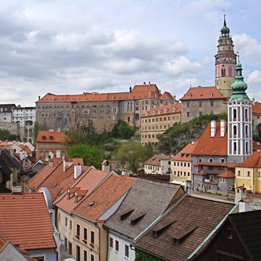

Outstanding Universal Value
Brief synthesis
The town of Český Krumlov is located in the South Bohemian Region of the Czech Republic. Situated on both banks of the Vltava (Moldau) river, the town was built below a magnificent castle founded in the 13th century. The river meander and rocky slopes of the castle hill are the most important elements which along with the link to the picturesque neighbouring landscape, determine not only the impressive urban composition of the historic centre but the dominating position of the castle as well.
The Historic Centre of Český Krumlov is an outstanding example of a small Central European medieval town whose architectural heritage has remained intact thanks to its peaceful evolution over more than several centuries. This feudal town, a former centre of a large estate owned by powerful noble families who played an important role in the political, economic and cultural history of Central Europe, was founded in the Middle Ages and underwent Renaissance and Baroque transformations. As it remained almost intact, it has retained its street layout, which is typical of planned medieval towns, as well as many historic buildings including their details such as the roof shapes, the decoration of Renaissance and Baroque facades, vaulted spaces, as well as original layouts and interiors.
The castle features Gothic, Late Gothic, Renaissance and Baroque elements. It is dominated by the Gothic Hrádek with its round tower; this was subsequently converted into a Baroque residence with the addition of a garden, the Bellaire summer pavilion, a winter riding school, and a unique Baroque theatre in 1766. Latrán (settlement developed to the east) and the town proper contain undisturbed ensembles of burgher houses, the oldest being in High Gothic style. They are notable for their facades, internal layouts, and decorative detail, and especially carved wooden Renaissance ceilings. Český Krumlov also experienced considerable ecclesiastical development illustrated by the major 15th century church of St. Vitus and monasteries of various preaching and itinerant orders.
Criterion (iv): Český Krumlov is an outstanding example of a Central European small town dating from the Middle Ages which owes the structure and buildings of its historic core to its economic importance and relatively undisturbed organic development over some five centuries. Český Krumlov grew up within a meander of the Vltava River, which provides a natural setting of great beauty. Its evolution over time is evident with startling clarity from its buildings and its urban infrastructure.

Integrity
All key elements conveying the Outstanding Universal Value of this property are inside the boundaries of the property. The property includes the historic centre of the town including the former aristocratic residence with an extensive garden. Its delimitation and size are appropriate. The buffer zone is well delimited too. The structure of the land use plan of the property and its buffer zone is stabilized. The visual integrity of the town is not threatened. Nevertheless, the pressure to allow new construction beyond the boundaries of the buffer zone is a potential danger to the integrity of the property.

Authenticity
The Historic Centre of Český Krumlov is a property of high authenticity. Its present form and appearance closely reflect the type of a town linked to the noble residence since the Middle Ages. The historic centre has preserved its original layout, as well as the characteristic castle-city relationship very clearly, thanks to its undisturbed development over several centuries. It remains untouched by the devastating effects of 19th-century industrialization, neglect during the communist era and thoughtless developments of the past decades. The high degree of authenticity is based on the dramatic setting of the urban townscape and its natural environment, as well as on a large number of preserved historic details. Restoration works on the facades of the buildings are carried out in compliance with strict international standards for heritage conservation. Only traditional materials and techniques are used.

Protection and management requirements
The Historic Centre of Český Krumlov is protected by Act No. 20/1987 on State Heritage Preservation as amended, as an urban conservation area (urban heritage reservation according the Act). The castle with the garden and a Parish church inside the historic centre are designated as national cultural heritage sites (under the Act mentioned above and under the relevant regulations); hence they enjoy the highest degree of legal protection. In addition, the historic centre includes several dozens of buildings that are designated as cultural heritage sites under the Act mentioned above. From a legal point of view, the protection of the buffer zone is strengthened by the fact that the Plešivec urban heritage zone is situated within its boundaries. The pressure to allow new construction in the buffer zone is regulated by the Act mentioned above and by the valid Land Use Plan, which stabilizes the functions of plots and areas within the whole town of Český Krumlov; that means property and its buffer zone. All specific details of building projects (new structures, their volumes and heights) are the subject of consideration by relevant authorities.
The responsibility for the property management is shared by the National Heritage Institute (a state organization) and the Municipality of Český Krumlov. Due to the extent of the property and its complicated ownership structure, maintenance and restoration of the various properties are subject to individual programmes that are coherent with the Programme for the Regeneration of Urban Heritage Reservations and Zones. Phase 4 of the Management Plan has been prepared in 2012, representing an up-date of the E- Management Plan. The main purpose of the Management Plan is to preserve the Outstanding Universal Value of the property. Since the beginning (2009), the document has been planned to apply to both key elements of the Municipal Heritage Site, the castle complex and the historic center.
Financial instruments for the conservation of the property mainly include grant schemes, funding through the programme of the Ministry of Culture of the Czech Republic allocated to the maintenance and conservation of the immovable cultural heritage and of areas under heritage preservation, as well as financial resources allocated from other public budgets. Since 2000, annual monitoring reports have been prepared at the national level to serve the World heritage property manager, the Ministry of Culture, the National Heritage Institute and other agencies involved.

